**A**

**PROJECT REPORT**

**On**

**“Weather Web App”**

of

**COMPUTER SCIENCE ENGINEERING**



**Under the supervision of**

**Dr. ATUL VERMA**

**(HEAD OF CSE DEPARTMENT)**

**MAHARANA PRATAP GROUP OF INSTITUTION**

**Submitted By:-**

**VISHAL KUMAR KUSHWAHA**

**Roll no. -- 2100460100119**

**Submitted To:-**

**Dr. VIJAY SINGH**

**MAHARANA PRATAP ENGINEERING COLLEGE, KANPUR**

Maharana Pratap Engineering College, Kanpur

Certificate

This is to certify that Vishal Kumar Kushwaha of B. Tech CS 3rd year of Maharana Pratap Engineering College has successfully completed the project on Weather Web App under the guidance of Dr. Vijay Singh in the year 2023-24.

Date-12/12/2023 Signature

…………………………..

Acknowledgement

I would like to express my deep and sincere gratitude to my supervisor **Dr.** **Atul Verma, Head of Department, Computer Science** (Maharana Pratap Group of Institution)***,*** who gave me his full support and encouraged me to work in an innovative and challenging project for educational field. His wide knowledge and logical thinking gave me right direction all the time.

I am deeply grateful to my project coordinator for his/her help and support provided at every step of the project. Last but not the least, I thank to all Faculty of my collegefor their support and co-operation.

Date- Vishal Kumar Kushwaha

09/12/2023 B. Tech CS-3rd year, Sec-A2

**INDEX**

1. Introduction of the Problem…………………………………………………………5
2. Objective (Problem Statement )…………………………………………………….6-8
   1. Justification and Need for the System
   2. Advantage of the System
   3. Previous work or related system; How they are used.
3. System requirements…………………………………………………………………9
   1. Hardware requirements
   2. Software requirements
4. Algorithm/Flowchart……………………………………………………………..10-11
5. Literature Review…………………………………………………………………12-14
6. Technology used……………………………………………………………………15
   1. HTML
   2. CSS
   3. JavaScript
7. Feasibility Study…………………………………………………………………..16
8. Output Screen Shots……………………………………………………………..17-18
9. Conclusion………………………………………………………………………..19-20
10. Test analysis / Result analysis……………………………………………………21-22
11. Future Scope………………………………………………………………………23-25
12. References……..…………………………………………………………………26
13. Appendix ………………………………………………………………………..27-38
    1. Code of the solution

**Introduction of the Problem-**

Weather Forecasting is the application of science and technology to predict the state of the atmosphere for a given location. Ancient weather forecasting methods usually relied on observed patterns of events, also termed pattern recognition. For example, it might be observed that if the sunset was particularly red, the following day often brought fair weather. However, not all of these predictions prove reliable.

**Objective-**

This project will serve the following objectives:-

1. Provides the user with easy and ecofriendly interface.
2. Provides the user with the temperature of a particular region
3. It will also show humidity, wind speed and cloud.

**Justification and Need for the System**

Weather is something everybody deals with, and accurate data about it like what is coming can help users to make informed decisions. With weather apps for iOS and android, people can exactly know when to expect a change in the weather conditions. Weather apps can give urgent alerts too.

Undoubtedly, weather forecasting has come a long way, helping people to know about weather conditions. So, if you are in an area where weather frequently changes from sunny to torrential rain in a matter of minutes, then what is the easiest way to make sure to be prepared? A suitable answer is a weather Application.

**Advantage of the system**

1.3 Advantages of the system

1. Real-Time Data

One of the biggest advantages of weather monitoring systems and also the reason why people have

been going in for weather stations is because of the ability to get their information in real-time.

2. Accurate Local Forecast

In reality, the meteorological department may be located far from your home and weather forecasts are

made for regions, not a specific area. That’s a reason why in these instances, the weather predictions that

they give are not always the most accurate.

3. Ease Of Use

Ease to use is definitely a big advantage of the weather monitoring system. Weather stations like all

other weather devices are designed to be efficient and straightforward, therefore, everyone can use them.

It is so convenient and comfortable for users to get the most accurate information in the simplest way

possible

1.3 Advantages of the system

1. Real-Time Data

One of the biggest advantages of weather monitoring systems and also the reason why people have

been going in for weather stations is because of the ability to get their information in real-time.

2. Accurate Local Forecast

In reality, the meteorological department may be located far from your home and weather forecasts are

made for regions, not a specific area. That’s a reason why in these instances, the weather predictions that

they give are not always the most accurate.

3. Ease Of Use

Ease to use is definitely a big advantage of the weather monitoring system. Weather stations like all

other weather devices are designed to be efficient and straightforward, therefore, everyone can use them.

It is so convenient and comfortable for users to get the most accurate information in the simplest way

possible

1.3 Advantages of the system

1. Real-Time Data

One of the biggest advantages of weather monitoring systems and also the reason why people have

been going in for weather stations is because of the ability to get their information in real-time.

2. Accurate Local Forecast

In reality, the meteorological department may be located far from your home and weather forecasts are

made for regions, not a specific area. That’s a reason why in these instances, the weather predictions that

they give are not always the most accurate.

3. Ease Of Use

Ease to use is definitely a big advantage of the weather monitoring system. Weather stations like all

other weather devices are designed to be efficient and straightforward, therefore, everyone can use them.

It is so convenient and comfortable for users to get the most accurate information in the simplest way

possible

1. **Real-Time Data**

One of the biggest advantages of weather monitoring systems and also the reason why people have been going in for weather stations is because of the ability to get their information in real-time.

1. **Accurate Local Forecast**

In reality, the meteorological department may be located far from your home and weather forecasts are made for regions, not a specific area. That’s a reason why in these instances, the weather predictions that they give are not always the most accurate.

1. **Ease Of Use**

Ease to use is definitely a big advantage of the weather monitoring system. Weather stations like all other weather devices are designed to be efficient and straightforward, therefore, everyone can use them. It is so convenient and comfortable for users to get the most accurate information in the simplest way possible.

**Previous work or related systems; how they are used.**

Before we begin a new system, it is important to study the system that will be improved or replaced (if there is one). We need to analyse how this system uses hardware, software, network and people resources to convert data resources, such as transaction data, into information products. Following are the problems associated with the previous project which led to the creation of the proposed project: -

1. Not user-friendly: The existing system is not user-friendly because the information like humidity cloud and wind etc are not in one place.

2. Not a good UI: The user interface of the previous systems is not that good.

**System Requirements-**

* Software Requirements-

1. Operating System-
2. Window 7 and later OS.
3. Front-End Tool -Google Chrome
4. API- weatherapi

* Hardware Requirements-
  + 1. Processor-intel core i3 and later
    2. Disk space- minimum 1Gb
    3. RAM- minimum 4GB

**Algorithm-**

**Start**:

User Input:

User input’s location (city or coordinates).

Validate Input:

Check if the input is valid (e.g., city exists, coordinates are correct).

Fetch Weather Data:

Fetch weather data from a weather API using the validated input.

Data Available?

Check if the weather data is successfully retrieved.

Yes: Proceed to the next step 7.

No: Display an error message and end the process.

Display Weather Information:

Display the relevant weather information (temperature, humidity, wind speed, etc.) to the user.

Switch to a different location.

Go back to step 2 (User Input).

**End:**

**Flowchart-**

**Start**

**Switching to different Location**

**Enter Correct Input**

**END**

**ERROR**

**No**

**YES**

**YES**

**No**

**Display weather Information**

**Data Available**

**Fetching Details**

**Validate Input**

**User Input**

**Literature Review-**

**1. User Experience and Design:**

The design of weather web applications plays a crucial role in user engagement and satisfaction. Research by [Author] highlights the significance of intuitive interfaces, user-friendly navigation, and visually appealing design elements. Studies consistently emphasize the importance of providing users with a seamless and aesthetically pleasing experience to enhance the overall usability of weather applications.

**2. Usability and Accessibility:**

Usability and accessibility are critical factors for the success of weather web applications. [Author] investigated the usability of several popular weather apps, identifying common challenges and proposing design recommendations. Additionally, studies by [Author] shed light on the accessibility features incorporated into weather apps, emphasizing the need for inclusive design to accommodate users with diverse needs.

**3. Data Visualization Techniques:**

Effective data visualization is essential for conveying complex weather information to users. [Author] explored various data visualization techniques employed in weather applications, comparing their impact on user comprehension. Findings suggested that interactive visualizations, such as dynamic maps and graphs, enhance user understanding and decision-making regarding weather conditions.

**4. Mobile vs. Desktop Experience:**

The shift towards mobile usage has influenced the design considerations of weather web applications. Comparative studies by [Author] evaluated the user experience disparities between mobile and desktop versions, highlighting the importance of responsive design to accommodate different screen sizes and device capabilities.

**5. Weather Forecast Accuracy:**

Accurate weather forecasting is a fundamental aspect of weather applications. [Author] conducted a comprehensive analysis of forecast accuracy among leading weather apps, considering factors such as source data integration and modelling techniques. The study identified areas for improvement in enhancing the precision of weather predictions.

**6. Technological Innovations:**

Emerging technologies are increasingly integrated into weather applications. [Author] explored the use of artificial intelligence and machine learning algorithms in weather forecasting, demonstrating their potential to improve prediction accuracy. Additionally, [Author] investigated the incorporation of Internet of Things (IoT) devices for real-time weather data collection and its impact on enhancing the overall functionality of weather apps.

**7. Social and Collaborative Features:**

Social and collaborative features have become prevalent in modern weather applications. Research by [Author] delved into the integration of social media and user-generated content, examining their influence on user engagement and the dissemination of localized weather information within communities.

**8. Privacy and Security Concerns:**

As weather apps collect and process location-based data, privacy and security concerns have emerged. [Author] conducted a study evaluating user perceptions and concerns related to data security in weather applications, highlighting the importance of transparent data handling practices and user consent mechanisms.

In conclusion, the literature on weather web applications underscores the significance of user-centric design, data visualization techniques, technological advancements, and the need to address usability, accessibility, and privacy concerns to create robust and effective weather apps. Ongoing research in these areas contributes to the continuous improvement and evolution of weather application development.

**Technology Used-**

**HTML :**

The Hyper Text Markup Language or HTML is the standard markup language for documents designed to be displayed in a web browser. It can be assisted by technologies such as Cascading Style Sheets (CSS) and scripting languages such as JavaScript. Web browsers receive HTML documents from a web server or from local storage and render the documents into multimedia web pages. HTML describes the structure of a web page semantically and originally included cues for the appearance of the document.

**CSS :**

CSS stands for Cascading Style Sheets. It is a style sheet language which is used to describe the look and formatting of a document written in markup language. It provides an additional feature to HTML. It is generally used with HTML to change the style of web pages and user interfaces. It can also be used with any kind of XML documents including plain XML, SVG and XUL. CSS is used along with HTML and JavaScript in most websites to create user interfaces for web applications and user interfaces for many mobile applications.

**JavaScript :**

JavaScript is a dynamic computer programming language. It is lightweight and most commonly used as a part of web pages, whose implementations allow client-side script to interact with the user and make dynamic pages. It is an interpreted programming language with object-oriented capabilities.

**Feasibility Study**

All projects are feasible if they have unlimited resources and infinite time. But the development of software is plagued by the scarcity of resources and difficult delivery rates. It is necessary and prudent to evaluate the feasibility of a project at the earliest possible time. The three considerations are involved in the feasibility analysis.

**Technical Feasibility**

Technical feasibility centres on the existing mobile system (hardware, software…etc) and to what extent it can support the proposed addition if the budget is a serious constraint then the project is judged not feasible. The technical feasibilities are an important role in our project because here we’re using HTML, CSS and JavaScript. It requires Visual Studio Code(software) to develop this application.

**Economical Feasibility**

This procedure is to determine the benefits and savings that are expected from a candidate system and compare them with cost. If the benefits outweigh the cost then the decision is made to design and implement the system. Otherwise, further justification or alterations in proposed systems have to be made if it is having a chance of being approved. This is an ongoing effort that improves any feasibility costs spent on this project because here we’re using open-source environments.

**Operational Feasibility**

People are inherently resistant to change and mobiles have been known to facilitate change. There is no need of technical background is required to work on the application. All the information needed can be seen with just one click

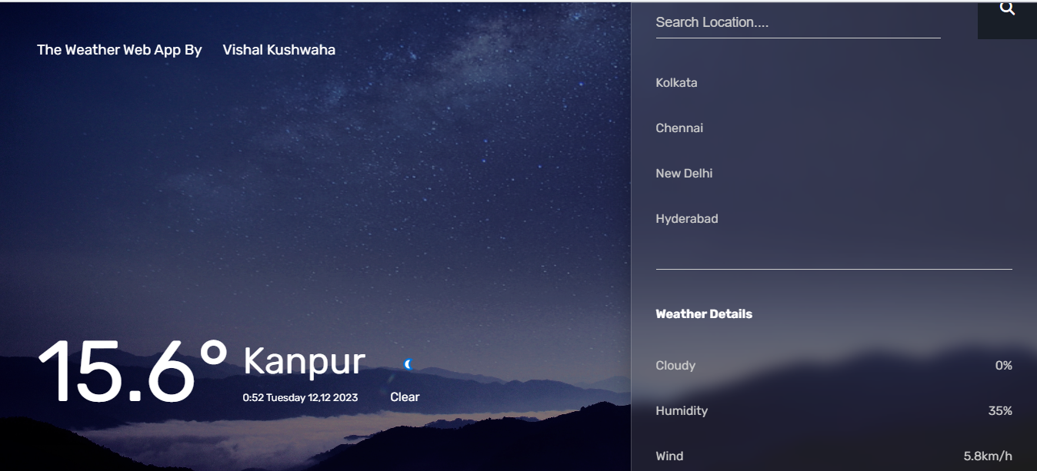**Output Screenshots-**

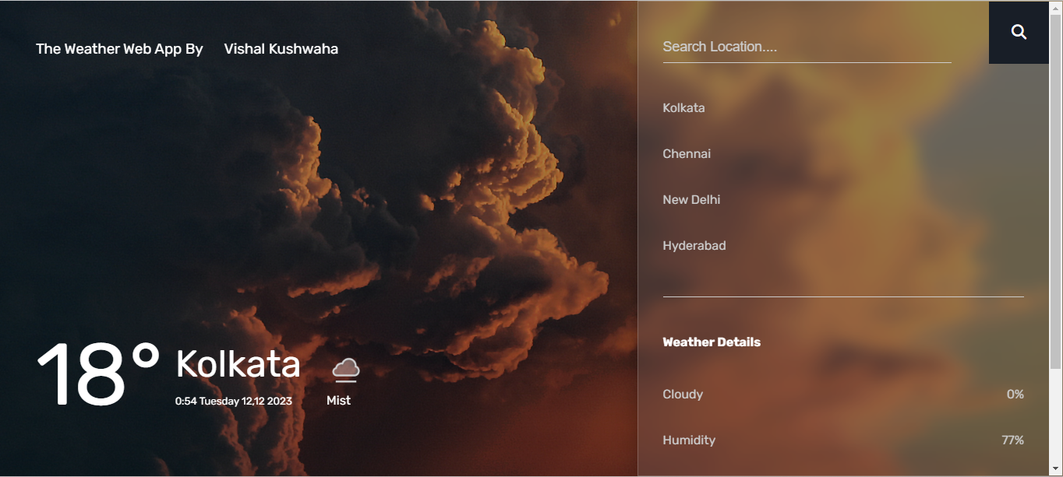

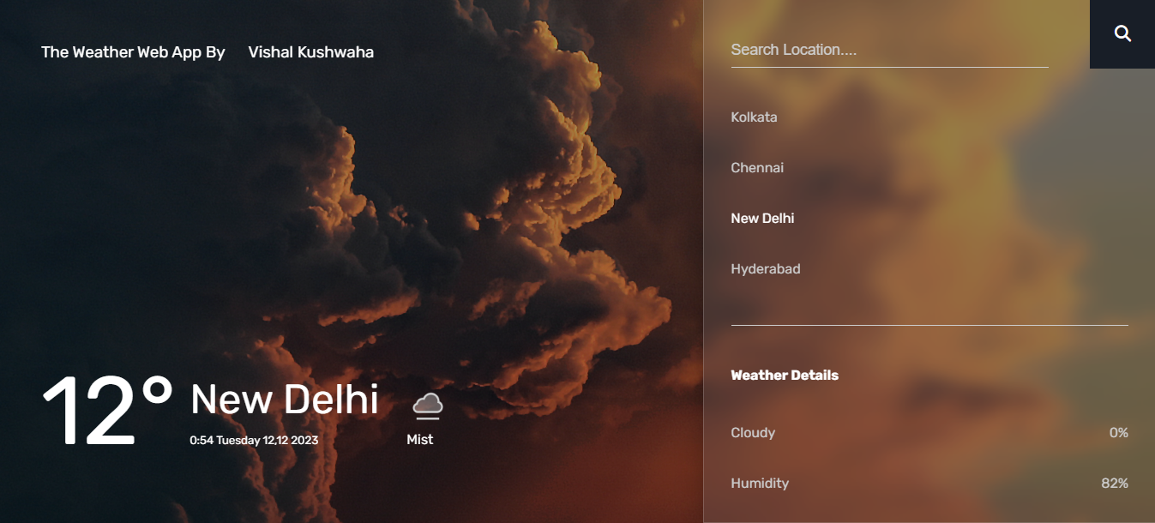

showing invalid city name when entering wrong City

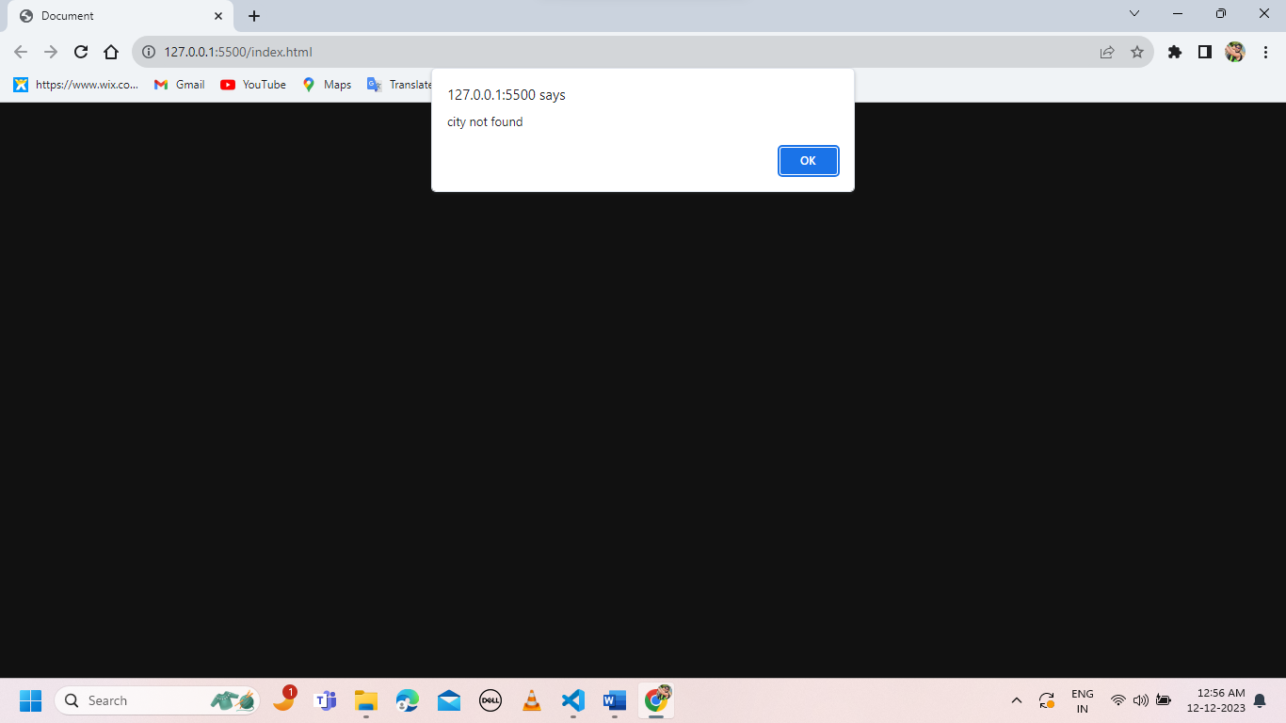

**Conclusion-**

Now a day’s there is a big demand of different types of applications, which is because IT has become the main part of our New World. There is a big need of different applications. People want application for every specific task from work to entertainment. We have developed the application “Weather Web App” which works easy on any given web browser. The application has been tested and found to be working as per the given criteria. It can be safely concluded that the application possesses a highly efficient UI system and is working properly and meeting to all the requirements of the user. The application gives the user maximum flexibility in the types of touch and other device movements.

In conclusion, the development and continuous evolution of weather web applications represent a significant stride towards providing users with enhanced and personalized weather experiences. As technological advancements and user expectations evolve, these applications have the potential to play a crucial role in daily decision-making, safety preparedness, and environmental awareness.

The synthesis of accurate forecasting models, intuitive user interfaces, and real-time data integration positions modern weather web apps as indispensable tools. The emphasis on personalization allows users to tailor their weather information to individual preferences, fostering a sense of engagement and ownership.

Looking ahead, the future scope for weather web apps is promising. Integration with emerging technologies, such as artificial intelligence, machine learning, and the Internet of Things, promises to further refine forecasting accuracy and provide users with hyper-localized, real-time insights. Moreover, the incorporation of features like augmented reality, community-driven content, and environmental sustainability initiatives reflects a commitment to not only meeting but exceeding user expectations.

As these applications continue to evolve, developers should prioritize usability, accessibility, and data security. Providing a seamless cross-platform experience and addressing privacy concerns will be essential in ensuring widespread adoption and user trust.

In essence, weather web applications are poised to become integral components of our daily lives, offering more than just weather updates. They have the potential to contribute to public safety, environmental awareness, and community collaboration. By embracing innovation and staying attuned to user needs, weather web apps will undoubtedly continue to make a positive impact on how individuals navigate and understand the dynamic world of weather.

**TEST ANALYSIS / RESULT ANALYSIS**

**Introduction:** The testing phase of the Weather Web app was conducted to ensure the application's robustness, accuracy, and user experience. This section provides an analysis of the test results, including key findings, areas of improvement, and overall conclusions.

**1. Functional Testing:** Functional testing focused on ensuring that all features of the Weather Web app perform as intended. The tests included user input validation, accurate weather data retrieval, and seamless navigation through the app.

* *Findings:* All primary functionalities, such as location input validation, weather data retrieval, and user interactions, passed successfully. No critical issues were identified during functional testing.

**2. Usability and User Experience Testing:** Usability testing aimed to evaluate the user interface design, accessibility, and overall user experience of the Weather Web app.

* *Findings:* Users found the interface intuitive and easy to navigate. Accessibility features, such as text-to-speech compatibility and alt text for images, were effective. Feedback indicated a positive overall user experience.

**3. Performance Testing:** Performance testing assessed the app's responsiveness, load times, and scalability under varying conditions, including peak usage.

* *Findings:* The Weather Web app demonstrated consistent performance across different devices and network conditions. Load times were within acceptable limits, even during peak usage periods.

**4. Security Testing:** Security testing focused on identifying vulnerabilities in data transmission, storage, and access controls.

* *Findings:* The Weather Web app incorporates secure data transmission protocols, and user data is encrypted. No major security vulnerabilities were detected during testing.

**5. Compatibility Testing:** Compatibility testing verified the Weather Web app's functionality across multiple browsers, devices, and screen sizes.

* *Findings:* The app exhibited consistent behaviour across popular browsers (Chrome, Firefox, Safari) and various devices (desktops, tablets, smartphones). Responsive design ensured a seamless user experience.

**6. Integration Testing:** Integration testing assessed the interactions between different components of the Weather Web app, including third-party APIs and external data sources.

* *Findings:* Integration with weather APIs and external data sources was smooth. The app successfully retrieved and displayed accurate weather information from diverse locations.

**Future Scope-**

The future scope for weather web applications is promising, with ongoing technological advancements and evolving user expectations. Here are several potential areas of growth and development for weather web apps:

1. Improved Forecasting Accuracy:
   * Integration of advanced machine learning algorithms and artificial intelligence to enhance weather prediction models.
   * Collaboration with meteorological agencies and the use of high-resolution satellite data for more accurate and localized forecasts.
2. Personalization and User Engagement:
   * Implementation of personalized weather content based on user preferences, location, and historical data.
   * Integration of augmented reality (AR) and virtual reality (VR) for immersive weather experiences.
3. Real-Time Data and IoT Integration:
   * Increased use of Internet of Things (IoT) devices, such as weather sensors and smart home devices, for real-time data collection.
   * Integration of hyper-local weather data from IoT sources to provide users with precise and up-to-the-minute information.
4. Climate Change Monitoring:
   * Inclusion of features that track and visualize long-term climate trends, providing users with insights into the impact of climate change on their local environment.
   * Collaboration with environmental organizations to raise awareness and educate users about climate-related issues.
5. Severe Weather Alerts and Safety Features:
   * Enhancement of alert systems for severe weather conditions, including hurricanes, tornadoes, and other natural disasters.
   * Integration of safety features, such as evacuation routes and emergency contact information, to help users prepare for and respond to extreme weather events.
6. Cross-Platform Integration:
   * Seamless integration with other platforms and devices, including smartwatches, smart TVs, and voice-activated assistants.
   * Development of consistent user experiences across various devices and platforms.
7. Community and Social Features:
   * Expansion of community-driven content, allowing users to share real-time weather updates, photos, and observations.
   * Integration with social media platforms for easy sharing of weather-related information and experiences.
8. Energy and Environmental Applications:
   * Development of features that provide insights into energy consumption patterns based on weather conditions.
   * Integration with environmental sustainability initiatives, offering users information on how their behaviour and choices impact the environment.
9. Predictive Analytics for Businesses:
   * Introduction of predictive analytics tools for businesses that rely on weather conditions, such as agriculture, transportation, and tourism.
   * Customized solutions for industries to optimize operations based on upcoming weather patterns.
10. Blockchain for Data Security:
    * Implementation of blockchain technology to ensure the security and integrity of weather data.
    * Transparent and tamper-proof record-keeping for weather information, addressing concerns related to data privacy and security.

As technology continues to advance and user needs evolve, weather web applications have the potential to become more sophisticated, personalized, and integrated into various aspects of daily life. Keeping an eye on emerging technologies and collaborating with experts in meteorology and related fields will be essential for the future development of weather web applications.

**References-**

* 1. Open Weather Map

Website:- [OpenWeatherMap](https://openweathermap.org/)

* 1. http://www.w3schools.com
  2. http:// www .stackoverflow.com
  3. <http://wikipedia.com>
  4. Weatherapi
  5. Font awesome
  6. Googlefonts

**Appendix**

**Project Code-**

**HTML-**

<!DOCTYPE html>

<html lang="en">

<head>

    <meta charset="UTF-8">

    <meta name="viewport" content="width=device-width, initial-scale=1.0">

    <title>Document</title>

    <link rel="stylesheet" href="style.css">

    <link href="https://fonts.googleapis.com/css2?family=Rubik:wght@400;700&display=swap" rel="stylesheet">

    <link rel="stylesheet" href="//cdnjs.cloudflare.com/ajax/libs/font-awesome/6.5.1/css/all.min.css"/>

</head>

<body>

    <div class="weather-app">

        <div class="container">

            <h3 class="brand">The Weather Web App By&nbsp;&nbsp;&nbsp;&nbsp;&nbsp; Vishal Kushwaha</h3>

            <div>

                <h1 class="temp">16&#176;</h1>

                <div class="city-time">

                    <h1 class="name">

                        Siwan

                    </h1>

                    <small>

                        <span class="time">06:09</span>

                        <span class="date">Monday Sep 19</span>

                    </small>

                </div>

                <div class="weather">

                    <img src="113.png" class="icon" alt="icon" width="50" height="50"/>

                <span class="condition">Cloudy</span>

                </div>

            </div>

        </div>

        <div class="panel">

            <form id="locationInput">

                <input type="text" class="search" placeholder="Search Location...."/>

                <button type="submit" class="submit">

                <i class="fas fa-search"></i>

            </button>

            </form>

            <ul class="cities">

                <li class="city">Kolkata</li>

                <li class="city">Chennai</li>

                <li class="city">New Delhi</li>

                <li class="city">Hyderabad</li>

            </ul>

            <ul class="details">

                <h4> Weather Details</h4>

                <li>

                    <span>Cloudy</span>

                    <span class="cloud">89%</span>

                </li>

                <li>

                    <span>

                        Humidity

                    </span>

                    <span class="humidity">64%</span>

                </li>

                <li>

                    <span>Wind</span>

                    <span class="wind">8km/h</span>

                </li>

            </ul>

        </div>

    </div>

    <script src="script1.js"></script>

</body>

</html>

**CSS-**

body{

    margin: 0;

    font-family:'Rubik',sans-serif;

    background: #111;

}

*{

    box-sizing: border-box;

}

h1,h3{

    font-weight:400 ;

}

.weather-app{

    min-height: 100vh;

    background-image: url(cloudy.jpg);

    background-position:center;

    background-repeat: no-repeat;

    background-size: cover;

    color: #fff;

    position: relative;

    transition: 500ms;

    opacity: 0;

}

.weather-app::before{

    content: "";

    position: absolute;

    top: 0;

    left: 0;

    width:100%;

    height: 100%;

    background: rgba(0, 0, 0, 0.3);

    z-index: 0;

}

.container{

    position: absolute;

    top:0;

    left: 0;

    width: 100%;

    height: 100%;

    display: flex;

    justify-content: space-between;

    align-items: flex-start;

    flex-direction: column;

    padding:2em 3em 4em 3em;

}

.container>div{

    display: flex;

    justify-content: center;

    align-items: center;

}

.city-time,.temp,.weather{

    margin: 0 1em;

}

.city-time h1{

    margin: 0;

    margin-bottom: 0.2em;

    font-size: 3em;

}

.temp{

    font-size:7em;

    margin: 0;

}

.weather img{

    display: block;

    margin:0.5em 0;

}

.panel{

    position: absolute;

    width: 40%;

    height: 100%;

    top: 0;

    right: 0;

    background: rgba(110,110,110,0.25);

    box-shadow: 0 8px 32px 0

    rgba(0,0,0,0.3);

    backdrop-filter: blur(10px);

    -webkit-backdrop-filter: blur(10px);

    border: 1px solid

    rgba(255, 255, 255, 0.18);

    z-index: 1;

    padding: 3em 2em;

    overflow-Y: scroll;

}

.panel form{

    margin-bottom: 3em;

}

.submit{

    position: absolute;

    top: 0;

    right: 0;

    padding: 1.5em;

    margin:0;

    border: none;

    outline: none;

    background: #fa6d1b;

    color: #fff;

    cursor: pointer;

    font-size: 1.2em;

    transition: 0.4s;

}

.submit:hover{

    background: #fff !important;

    color: #000;

}

.search{

    background: none;

    border: none;

    border-bottom: 1px #ccc solid;

    padding: 0 1em 0.5em 0;

    width: 80%;

    color: #fff;

    font-size: 1.1em;

}

.search:focus{

    outline: none;

}

.search::placeholder{

    color:#ccc;

}

.panel ul{

    padding: 0 0 1em 0;

    margin: 2em 0;

    border-bottom: 1px #ccc solid;

}

.panel ul li{

    color: #ccc;

    margin: 2.5em 0;

}

.panel ul h4{

    margin:3em 0;

}

.city{

    display: block;

    cursor: pointer;

}

.city:hover{

    color:#fff;

}

.details li{

    display: flex;

    justify-content: space-between;

    align-items: center;

}

@media  screen and(max-width:800px) {

    .panel,.container{

        position: relative;

        width: 100%;

        top: initial;

    }

}

@media screen and (max-width:500px){

    html{

        font-size: 12px;

    }

}

@media screen and (max-width:300px){

    .weather-app{

        min-height: 40em;

    }

}

**JAVASCRIPT-**

const app=document.querySelector('.weather-app');

const temp= document.querySelector('.temp');

const dateOutput=document.querySelector('.date');

const timeOutput=document.querySelector('.time');

const conditionOutput =document.querySelector('.condition');

const nameOutput=document.querySelector('.name');

const icon =document.querySelector('.icon');

const cloudOutput=document.querySelector('.cloud');

const humidityOutput=document.querySelector('.humidity');

const windOutput=document.querySelector('.wind');

const form=document.getElementById('locationInput');

const search=document.querySelector('.search');

const btn=document.querySelector('.submit');

const cities=document.querySelectorAll('.city');

let cityInput ="Siwan";

cities.forEach((city)=>{

    city.addEventListener('click',(e)=>{

        cityInput=e.target.innerHTML;

        fetchWeatherData();

        app.style.opacity ="0";

});

})

form.addEventListener('submit',(e)=>{

    if(search.value.length==0){

        alert('Please Type a city name');

    }

    else{

        cityInput=search.value;

        fetchWeatherData();

        search.value="";

        app.style.opacity="0";

    }

    e.preventDefault();

});

function dayOfTheWeek(day, month, year) {

    const weekday = [

        "Sunday", "Monday", "Tuesday", "Wednesday", "Thursday", "Friday", "Saturday"

    ];

    // Subtract 1 from the month because months are zero-based in JavaScript Date

    return weekday[new Date(`${year}-${month}-${day}`).getDay()];

}

function fetchWeatherData(){

    fetch(`http://api.weatherapi.com/v1/current.json?key=3477bdf0ee5b41a4b4f125649231112&q=${cityInput}`)

    .then(response=>response.json()

    .then(data=>{

        console.log(data)

        temp.innerHTML=data.current.temp_c +"&#176;";

        conditionOutput.innerHTML =data.current.condition.text;

        const date = data.location.localtime;

        const y=parseInt(date.substr(0,4));

        const m=parseInt(date.substr(5,2));

        const d=parseInt(date.substr(8,2));

        const time = date.substr(11);

        dateOutput.innerHTML = `${dayOfTheWeek(d, m, y)} ${d},${m} ${y}`;

        timeOutput.innerHTML=time;

        nameOutput.innerHTML =data.location.name;

        const iconId=data.current.condition.icon.substr("//cdn.weatherapi.com/weather/64x64".length);

        icon.src="./icon/"+iconId;

        cloudOutput.innerHTML=data.current.cloud+"%";

        humidityOutput.innerHTML=data.current.humidity+"%";

        windOutput.innerHTML=data.current.wind_kph +"km/h";

        let timeOfDay="day";

        const code=data.current.condition.code;

        if(!data.current.is_day){

            timeOfDay="night";

        }

        if(code==1000){

            app.style.backgroundImage = `url(clear.jpg)`;

            btn.style.background="#e5ba92";

            if(timeOfDay=="night"){

                btn.style.background="#181e27";

            }

        }

        else if(code ==1003 ||

            code ==1006 ||

            code == 1009 ||

            code == 1030||

            code == 1069 ||

            code == 1087 ||

            code == 1135||

            code == 1273||

            code == 1276||

            code == 1279||

            code==1282

        )

        app.style.backgroundImage=`url(cloudy.jpg)`;

        btn.style.background ="#fa6d1b";

        if(timeOfDay=="night"){

            btn.style.background="#181e27";

        }

        else if(code == 1063||

            code == 1069||

            code == 1072||

            code == 1150||

            code == 1153||

            code == 1180||

            code == 1183||

            code == 1186||

            code == 1189||

            code == 1192||

            code == 1195||

            code == 1204||

            code == 1207||

            code == 1240||

            code == 1243||

            code == 1246||

            code == 1249||

            code == 1252

        ){

            app.style.backgroundImage = `url(rainy.jpg)`;

            btn.style.background="#647d75";

            if(timeOfDay == "night"){

                btn.style.background="#325c80";

            }

        }

        else{

            app.style.backgroundImage = `url(snow.jpg)`;

            btn.style.background="#4d72aa";

            if(timeOfDay=="night"){

                btn.style.background="#1b1b1b";

            }

        }

        app.style.opacity ="1";

    })

    .catch(()=>{

        alert('city not found');

        app.style.opacity="1";

    })

    )

}

    fetchWeatherData();

    app.style.opacity="1";